Hvad vælger du?
1
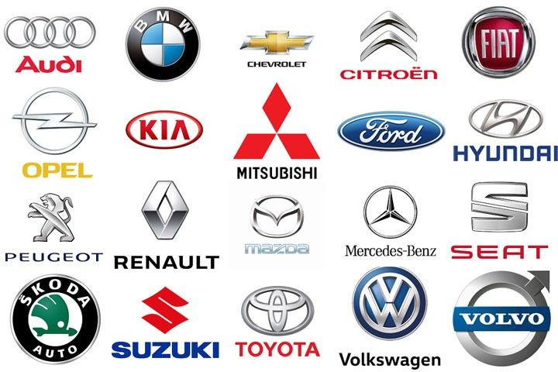
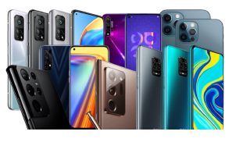

2

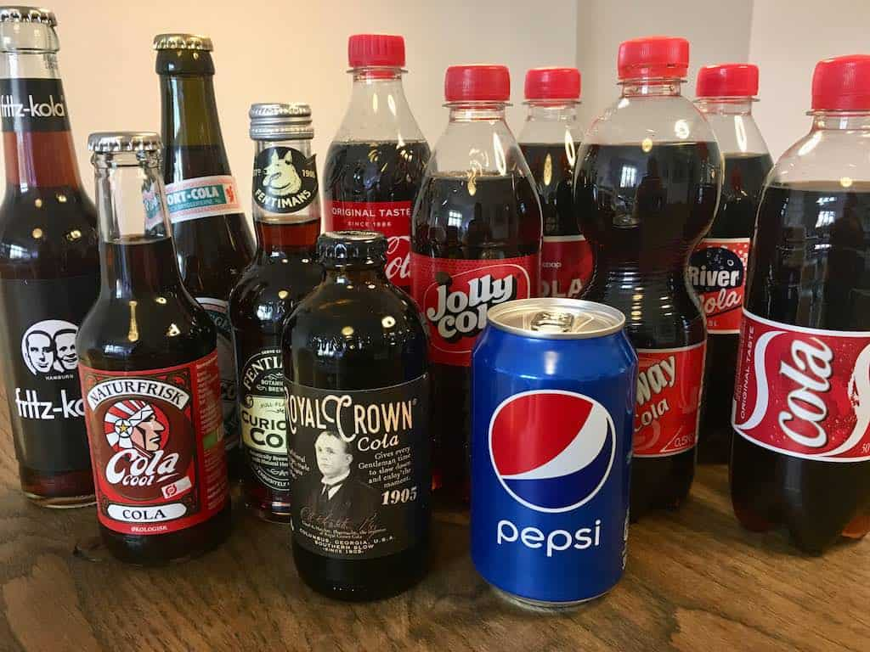
3
4

Mobil ______________________________
Hmmm – hvorfor? ________________________________________________________________

Bil _________________________________
Hmmm – hvorfor? ________________________________________________________________

Cola _______________________________
Hmmm – hvorfor? ________________________________________________________________

Ungdomsuddannelse _________________
Hmmm – hvorfor? ________________________________________________________________

